24th Jan 2026 – HNF PLANNING UPDATE
For links to PCC web sites regarding Planning and Licensing please see
the addendum at the end of this report.
~~~~~~~~~~~~~~~~~~~~~~~~~~~~~~~~~~~~~~~~~~~~~~~~~~~~~~~~~~~~~~~~~~~~~~~~~~~~~~~~~~~~~~~~~~~
LICENSING APPLICATIONS (NEW)
None
~~~~~~~~~~~~~~~~~~~~~~~~~~~~~~~~~~~~~~~~~~
PLANNING APPLICATIONS (NEW)

25/01212/LBC - Flat 2, 216 Citadel Road
Installation of extractor fan unit and associated works.
I have a free-standing bath and floor mounted tap in my bedroom next to the back external wall. A small waste pipe has been drilled through the external and connected to the main waste pipe of the building.
I have been advised that a 100mm extractor fan is required and the electrics are in place for this to happen, but I have been advised that I need LBC.
Comments by 17th Feb
~~~~~~~~~~~~~~~~~~~~~~~~~~~~~~~~~~~~~~~~~~

25/01654/FUL - Plymouth Register Office, 49 Lockyer Street
Demolition of existing building and construction of residential development with commercial (use class E) on ground floor and associated works.
This design was presented by the developer’s architect at an open day at the Bowling Green clubhouse on 15th Oct 2025 and then the Pre-application was discussed at the 22nd of Oct HNF meeting.
The meeting attendees agreed to generally support the developers Pre-App design and that the HNF would comment further, and in more detail, when the full planning application was submitted.
See Appendix 1 at the end of this report for further details.
University Hospitals Plymouth NHS Trust seeks a contribution of £23,865 i.a.w. Section 106 of the Town and Country Planning Act 1990 that allows the Local Planning Authority to request that a developer contributes towards the impact a development creates on the capacity to provide services.
Concern has been raised by a resident in Windsor Place regarding being directly overlooked by some of the flats into the rooms at the rear of their property.
Comments by 10th Feb
~~~~~~~~~~~~~~~~~~~~~~~~~~~~~~~~~~~~~~~~~~

25/01448/LBC - 3 Elliot Terrace
Repairs to existing roof including new roof covering and insulation and associated gutter and lead works
Replacement of flat roof covering to the rear of the property. The flat roof will include an increase in the height, due to meeting the building regulations Part L. The existing roof will remain in place and the new covering will be installed over it to increase insulation values.
Existing materials and finishes:
Rear Tenement combined Terrace Flat Roof Existing: Bitumen felt roof covering. Cast iron railing posts; Lead flashings
Proposed materials and finishes:
Rear Tenement combined Terrace Flat Roof Proposed: Fully coat entire flat roof surfaces, applying enhanced adhered bitumen primers. Supply and install new high performance felt system, comprising of underfelts and polyester strand reinforced cap sheet; including UV surface protection granules. All new felts to fully cover and waterproofing the integral gulley sump. Wrap and seal the base of railing posts with the application of waterproof liquid compounds. Chase and redress existing lead flashings. The insulation will raise the roof by 130mm and the integral gully by 30mm
Comments by 10th Feb
~~~~~~~~~~~~~~~~~~~~~~~~~~~~~~~~~~~~~~~~~~

PLANNING APPLICATIONS (NEW)

26/00003/LBC & 26/00002/FUL - 71 Citadel Road
Change of use of hotel (Class C1) to 12-bed HMO (Sui Generis) and associated works (part retrospective)
For reference:
This terrace, Nos 59-73 are all Grade II listed.
71 was formally The Retreat Guest House.
67 & 69 are owned by Live West Homes housing association as mixed lodgings
73 is currently being advertised as an HMO with bedroom rentals in a newly refurbished ten-bed house. I cannot find any planning applications for any refurbishment of this property, and I also cannot advise if this property is an approved HMO as PCC do not share HMO information with the HNF.

The owner states
A light touch pre-application enquiry (dated 17th November 2025) confirms a confused planning position. The council's HMO database identifies the Retreat Guest House as an established HMO; however, the property does not hold an HMO licence. The HMO Licensing team advised the client that planning permission was required before a licence could be issued. This discrepancy has therefore prompted the submission of this part-retrospective planning application.

Residents Objection
I strongly object to the proposed change of use of the hotel which would cause significant harm to the character, function, and heritage of this Conservation Area. The Hotel is a long-established visitor accommodation and contributes significantly to the tourism and heritage character of Plymouth Hoe.
The proposed conversion to a 12-bed HMO would result in the permanent loss of tourist accommodation in a prominent and sustainable location, undermining the vitality of this key destination. The scale and nature of the HMO use would introduce increased noise, disturbance, refuse, and pressure on on-street parking, which is out of keeping with the existing character of the area and would negatively affect neighbouring residents and businesses.
Comments by 3rd Feb
~~~~~~~~~~~~~~~~~~~~~~~~~~~~~~~~~~~~~~~~~~

PLANNING APPLICATIONS (PREVIOUS)

25/01639/FUL - Rivage Apartments, Hoe Road
Removal and replacement of existing combustible cladding and external wall elements with new non-combustible and associated works.
Combustible materials have been found to exist within the primary materials used in the construction of the external walls. Concerns were also raised over the absence and incorrect fitting of vertical and horizontal fire and cavity barriers, as well as cavity closers to the window openings.
In order to address these issues and ensure the fire risk for the building is reduced, full planning permission is being sought for the removal of the existing combustible external wall systems, including flammable elements behind, and the installation of a replacement system with new non-combustible alternatives, plus associated works.

Awaiting decision
~~~~~~~~~~~~~~~~~~~~~~~~~~~~~~~~~~~~~~~~~~

25/01637/MOR - Tinside Pool, Hoe Road
Pre-application to erect protective railings along the colonnade and towards building B.
Concern has been raised that when the hoarding is removed, on completion of the current ongoing works, that there is a risk of damage to the new structures from antisocial behaviour and vandalism.
The covered colonnade area north of the Lido has long experienced high levels of antisocial behaviour, including vandalism and graffiti. It is therefore felt that without a more appropriate barrier in place, it is considered that there is a significant risk that the new terraced area will be subject to serious vandalism. Similar issues apply to the roof terrace of Building B.
Pre-Application
~~~~~~~~~~~~~~~~~~~~~~~~~~~~~~~~~~~~~~~~~~

25/01631/FUL - Former Quality Hotel Site, Cliff Road West Hoe
Temporary change of use for the storage of public realm construction materials on the entire site for a period of 18 months (retrospective).
The west side of the site was being used by PCC contractors for Armada Way works and the east side by the Azure flat contractors. After the Azure storage area was no longer needed PCC started using the whole site for the Armada Way works without permission.
This is therefore a retrospective planning application for this change of use to the eastern half of the site, but the entire site is now subject to this new temporary application to cover a period of 18 months to ensure it is regulated for the full period of the city centre public realm works. The amounts of materials held here will significantly diminish over the next 6 months as the current public realm projects become complete, but there will be some valuable surplus natural stone materials left over. What is left will be materials required for the maintenance of the city’s new public realm schemes as well as the upkeep of the city’s historic streets and spaces.
What I cannot find on the PCC planning website is the Site Notice and cutoff date for comments.
I also cannot find any mention that the previous applications rules on site working hours and traffic flow arrangements apply to this planning application, given that PCC contractors can now potentially enter and exit from Leigham St which was not possible before.
Awaiting decision
~~~~~~~~~~~~~~~~~~~~~~~~~~~~~~~~~~~~~~~~~~

25/01603/MOR - New Continental Hotel, Millbay Road
Pre-application to re-order parts of the lower floors to create additional rooms, removal of external rear staircase, and installation of wheelchair lift at the front entrance, along with the removal of some other modern additions.

This consists of removing existing C20 stud partition walls and relocating the new partition walls to subdivide the spaces into individual guest rooms and rooms supporting services. Furthermore, it is proposed to remove the modern addition of the rear staircase to the first floor and insert an elevator adjacent to the existing staircase in the northwest corner of the building.
Pre-Application
~~~~~~~~~~~~~~~~~~~~~~~~~~~~~~~~~~~~~~~~~~

PLANNING APPLICATIONS (PREVIOUS)
25/01608/FUL - Bowling Green, Armada Way, The Hoe
Temporary external artwork for the Beryl Cook 100th anniversary celebrations. See images on the next page
The project objective is to create and unveil a series of figures inspired by paintings by Plymouth artist, Beryl Cook, to coincide with the opening of a major exhibition of the artist’s work at The Box on 24 January 2026. Beryl Cook was one of the most notable artists to have lived in Plymouth, and 2026 will mark what would have been her 100th birthday.
The proposal for a trail of 3D Beryl Cook figures was first made by John Cabello of Parade Antiques, The Barbican, Plymouth in 2015 and this iteration of the proposal of the trail was initiated by Council Leader Tudor Evans and is being delivered by The Box in partnership with the Theatre Royal Plymouth, in close consultation with Beryl Cook’s family who now look after the late artist’s estate. The cartoon type figure is based on a Beryl Cook painting entitled “Sabotage” and the application has been submitted by one of the four assistant curators at ‘The Box’ Museum & Gallery. The sculpture will be birch ply and steel, surrounded by polystyrene and encased in fibreglass. Beryl was a long-time resident of ‘The Hoe’ and a Blue Plaque commemorating her last home is on display in Alfred St.
The timeline is:
09 Dec - Planning Application submitted
16 Jan - Closing date for comments
22 Jan - Installation of figure at proposed location
24 Jan - Exhibition at The Box opens to the public
31 May - Exhibition closes
22 July - Installed figures are removed and restoration of site complete
31st Dec - The PCC Heritage Officer
The proposed statue is described by the applicant as a reminder of the playful nature of the artist Beryl Cook and the intention is to provide an opportunity for members of the public to interact with the figure for taking photographs. The cheeky pose of the proposed 2m high cartoon like statue of the woman poking an opponent in the backside is not considered to be of a design or material which is respectful or sympathetic to the character or significance of the heritage assets at the proposed location almost at the foot of the Grade I listed Plymouth Naval War Memorial and within the Grade II listed 'The Hoe' park and garden. It is therefore not in accordance with the Plymouth City Centre Conservation Area Appraisal and Management Plan (CAAMP) and that an alternative site should be sought.
22nd Jan - Historic England
We believe that there may well be a location, within the registered park and garden, that could accommodate such a cheeky homage to the well-loved local artist Beryl Cook. However, given the colourful expression and frivolous nature of the proposed installation, we think that the current, proposed location will fundamentally conflict with the sombre ethos of the Naval War Memorial. The grade I listing is of the highest significance, so requires the greatest weight of consideration. The installation of the sculpture, in such close proximity (14m) does cause harm, even if the harm is of a temporary nature. The applicant has not offered a justification for the harm or described how the benefits might outweigh that harm. There could be strategies for mitigating such harm, but these do not seem to have been considered. We recognise the site-specific nature of the installation that connects it directly with the Plymouth Bowling Club. So, we wonder whether there might be an alternative location for the sculpture, still connected to the Bowling Club; but, significantly further away from the Naval War Memorial; ideally, without a direct line of sight between the two. Given the harm being caused to a grade I listed asset, with the installation in the current proposed location, this strategy could provide a route for avoiding any harm at all.
We consider that the issues and safeguards outlined in our advice need to be addressed in order for the application to meet the requirements of paragraphs 212 and 213 of the NPPF.
23rd Jan - Planning Officers Report
Officers acknowledge that further consideration could be given to the position of the sculpture so that it was further away from the War Memorial but still adjacent to the bowling green due to the concept of the sculpture. Officers sought an amended location from the applicant but amended plans were not submitted. It is considered, therefore, that the scheme would lead to less than substantial harm to the setting of nearby listed buildings/structures, the listed Park, and the wider conservation area - but that the level of harm, due to the size of the sculpture, its short temporary nature and strong association with Plymouth and the bowling green would be at the lower end of such. Paragraph 215 of the NPPF requires sufficient public benefits to outweigh any harm caused - and (planning) Officers are of the view that sufficient public benefit can be found in the celebration of a well-known artist and their strong association with the city.
Granted
PLANNING APPLICATIONS (NEW)
25/01608/FUL - Bowling Green, Armada Way, The Hoe (continued)
Temporary external artwork for the Beryl Cook 100th anniversary celebrations.

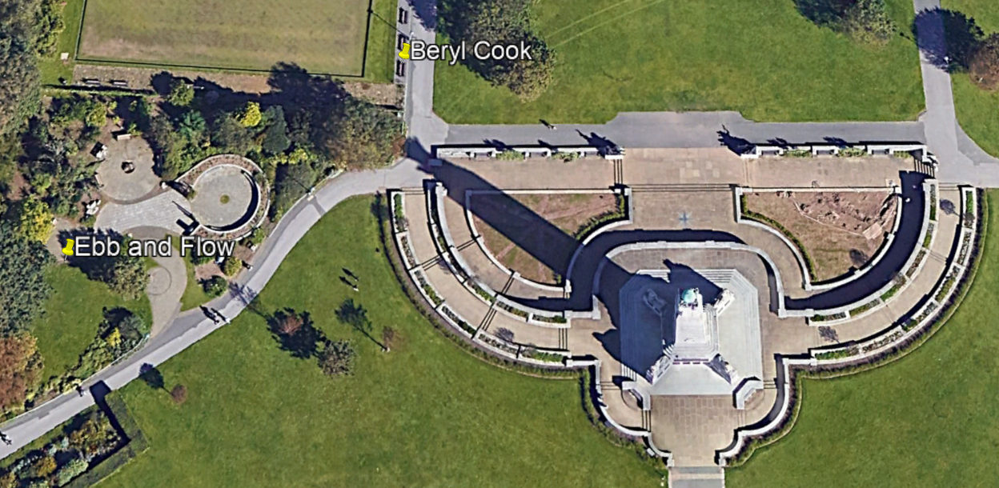

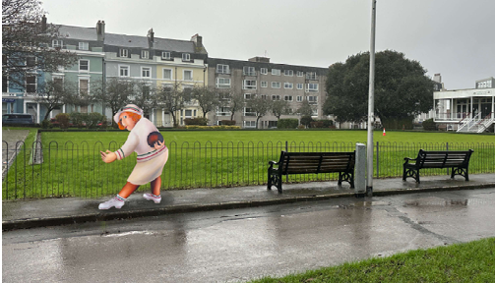

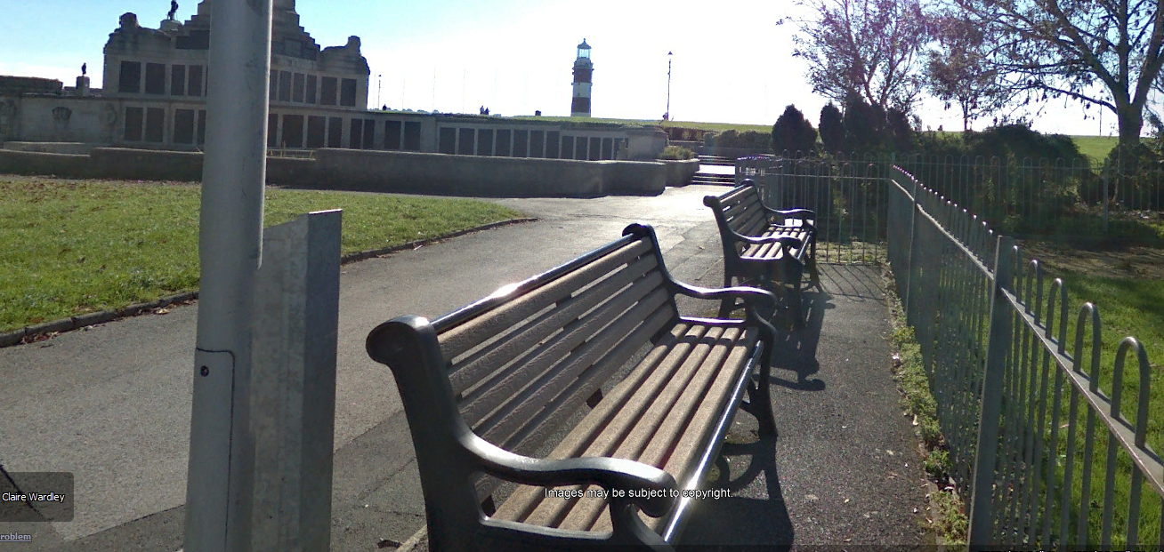

PLANNING APPLICATIONS (PREVIOUS)
25/01588/FUL - 6 Sussex Place
Separation of basement from the main dwelling to form self- contained basement flat.
The owner wishes to separate the property to create two properties, noting that other houses in the terrace have previously been converted.

Awaiting Decision
~~~~~~~~~~~~~~~~~~~~~~~~~~~~~~~~~~~~~~~~~~
25/01465/LBC - 67 Citadel Road
Replacement of door and overhead fan light

The owner, Live West Housing association, states
The proposal seeks to replace the existing, non-original door estimated to have been fitted in around 2000, with a like-for-like painted timber replacement, matching the existing door in terms of:
• Overall dimensions and proportions
• Panel configuration and glazing arrangement
• Painted finish and colour
• Traditional detailing appropriate to the character of the building Heritage Impact Assessment
The replacement door will be installed within the existing opening, with no alterations to the surrounding historic fabric, including the door surround, reveals, or adjacent masonry

Awaiting Decision
~~~~~~~~~~~~~~~~~~~~~~~~~~~~~~~~~~~~~~~~~~
25/01554/LBC - Flat 7, 5 Elliot Terrace
Formation of opening in internal wall.
Install an opening between the windowless Kitchen and the Dining area of the Sitting Room.
PCC Historic Environment Officer
The proposed internal changes are not considered harmful to the overall character or significance of the Grade II* Listed Building.
Granted
~~~~~~~~~~~~~~~~~~~~~~~~~~~~~~~~~~~~~~~~~~

PLANNING APPLICATIONS (PREVIOUS)

25/01341/FUL - Peace Garden, The Hoe.

Installation of Ebb and Flow sculpture, and accompanying plaque, within the Peace Garden.
This The 'Ebb and Flow' artwork was installed in the city centre Civic Square outside the Council House Building on Armada Way. It was created and funded by Babcock International in partnership with Arts University Plymouth.
PCCs Project Manager has submitted this planning application to relocate the sculpture from the Civic Sq to the Peace Garden on ‘The Hoe’.
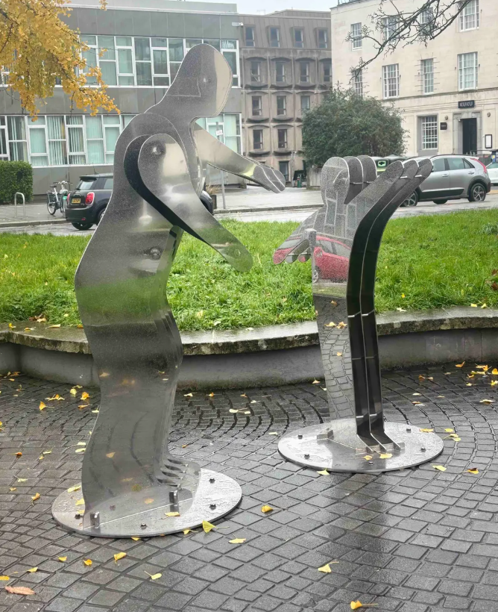
The Hoe Neighbourhood Forum
The HNF, after being contacted by members who had read about the proposal in HNF email planning circulars, noting that there was no Dec HNF meeting, raised concerns with Penny and myself. These were not over the statue itself but the chosen new location and the removal of two benches to a different area of the Peace garden and therefore HNF submitted the following objection.
“We would like to object to this planning application: Whilst the sculpture is welcomed it is felt by many members that the Peace Garden is not the ideal location. It was also felt that removal of the seating would reduce the areas of separated quiet contemplation from three to two.
The HNF would like to point out that there has been no consultation regarding this proposal and given that councillors attend our regular monthly meetings it would have been courteous to have done so.
We also ask what other locations PCC identified for this sculpture and why these were rejected in favour of the Peace Garden? Why not leave it where it is in the Civic Square?
Lastly, we agree with The Gardens Trust that there needs to be a policy to steer what is and what is not acceptable within The Hoe landscape areas and the extent to which further sculptures, memorials and art installations will be permitted in the future. The Forum would welcome the opportunity to collaborate on such a policy.”

PLANNING APPLICATIONS (PREVIOUS)

25/01341/FUL - Peace Garden, The Hoe.

Historic England
Stated that PCC should seek the views of your trained specialist conservation officer.

PCC Historic Environment officer
Assessed the planning application, especially the chosen location and recommended that PCC refuse permission on the grounds that a more suitable location should be found. They also questioned that “the Heritage Statement makes no assessment of the potential harm to and potential public benefits of the proposal to the setting of the majority of heritage assets impacted by the proposal.

PCC Design and Conservation Team Manager
Confirmed that “This fact is a serious omission and the (heritage) officer is right to point it out.”. They then went on to state that “The purpose of this (my) note is to clarify the position of the design and conservation team. It does not seek to question or revise the professional assessments already made but adds clarity on levels of harm and introduces additional views, including my own”.
They then go on to say; “Upon further discussion with colleagues, there are mixed views on the current proposal. However, it does have support from democratically elected members. I have also discussed with some officers within my own team (and other council teams) who are positive about the sculpture. I happen to share this view from an urban design perspective. I also think that the “meaning” of the sculpture is fully aligned with the military, commemoration and reflection theme of the surrounding assets. I therefore suggest that the Peace Garden location is appropriate for a sculpture of this type”.
This advice led to the Historic Environment officer’s advice being overruled and the planning application was approved.
It should be noted that the HNF is in support of Plymouth having public sculpture attractions and when visiting other cities members have followed their sculpture trails. However, in this case many members do not support the tranquil peace garden as being the correct location for a piece of public art.
See Appendix 2 at the end of this report for the full transcript.
Granted
~~~~~~~~~~~~~~~~~~~~~~~~~~~~~~~~~~~~~~~~~~

PLANNING APPLICATIONS (PREVIOUS)

25/01485/LBC - Apartment 18, The Grand - 24 Elliot Street
Replacement windows, Air Source Heat Pump to rear elevation and associated interior works.
The applicant states that the windows and internal joinery to the Solarium are constructed from modern softwood and MDF. The glass is modern tin-float single-glazing, and the plaster is modern gypsum. The space is neither heated nor ventilated and is adversely affected by the weather, leading to large temperature swings, condensation, mould and decay. The windows to the rear bedroom are the same; the room is north-facing, cold and uncomfortable.
Their proposal is for the:-
- Replacement of sashes
- Repair and replacement of deteriorated softwood joinery
- Installation of underfloor heating within the Solarium
- Installation of an air-source heat pump in the rear courtyard
Further to a Pre-App meeting with the PCC Conservation Officer the owners were asked to undertake further investigations into the glazed timber infill wall. These findings have informed adjustments to the proposals, which have been complemented by a Chartered Architect & Heritage Specialists Impact Assessment.
The Board of the Freehold Company of the Grand, has supported the proposed replacement windows.
However, they informed the Planning Department that any changes or new installations outside of the individual apartments cannot be implemented without the approval of the Board. They also stated that whilst The Board appreciates the possible benefits of heat pumps it does not approve of devices placed outside of apartments as this could set a precedence.

Awaiting Decision
~~~~~~~~~~~~~~~~~~~~~~~~~~~~~~~~~~~~~~~~~~

25/01465/LBC - 67 Citadel Road
25/01466/LBC - 69 Citadel Road
Both applications are for the replacement of a single rear door in each property.
The application by Live West Homes housing association is to replace the existing poor condition rear doors with a like for like replacement. This will preserve the character and appearance of the terrace whilst ensuring the long-term weatherproofing of the property as well as providing improved security and energy efficiency.
PCC have granted an extension of time for the provision of a Heritage Statement.
This has now been supplied and concludes that:-
The replacement of the existing entrance door at No. 67 Citadel Road with a like-for-like timber door is justified on the basis that:
• The existing door is not original and does not constitute listed fabric
• The proposed replacement preserves the established appearance of the building
• No historic fabric will be lost or altered
• The significance of the listed building will be preserved

Awaiting Decision
~~~~~~~~~~~~~~~~~~~~~~~~~~~~~~~~~~~~~~~~~~

25/01381/TCO - 30 Athenaeum Street
Ash - 2-3m shaping all round.

Approved
~~~~~~~~~~~~~~~~~~~~~~~~~~~~~~~~~~~~~~~~~~

PLANNING APPLICATIONS (PREVIOUS)

25/01358/MOR - Flats 1, 5, 6, 7, 8, 9 & 11 - 5 & 6 Elliot Terrace.
Pre-application to ascertain if Listed Building Consent is required for like for like repairs following water damage.

Summary of issues and officer views
Officers visited the site with the applicant and the Historic Environment Officer on 11th November 2025 to get a better understanding of the issues at hand. Further information was then supplied by the applicant in the form of draft Schedules of Works.
It should also be noted that, following the site visit, it was confirmed in writing that some of the damaged plaster could be removed under Section 9.3 of the Planning (Listed Buildings and Conservation Areas) Act 1990 as ‘urgently necessary works’ to allow for the drying of the walls to take place.
Three draft Schedules of Works were provided, each covering different flats, as the works are related to three separate insurance claims. Officers’ advise that any future listed building consent application deals with everything under one scheme.
Having been through the draft Schedules of Works, Officers consider them to be suitable – and reflect the discussions had on site regarding the extent of the works required. They provide a suitable level of detail as the proposed work – and are very specific in terms of which areas of plaster, etc., need to be removed. This would limit any unnecessary removal of plaster which remains in good condition. The documents also make suitable arrangements as to remaining historic features, such as cornicing, to ensure that these features are suitably protected.
Officers understand the requirement for the works proposed and consider that repairing the damage caused by water ingress should be undertaken to ensure that the building can continue to be used going forward.
As such, given the considered nature of the repair works proposed here, Officers would likely be able to support a listed building consent application for the scheme should one be submitted.
If the applicant is minded to pursue applying for listed building consent for the proposal, then the following information would need to be provided at application stage:
- A completed listed building consent application form.
- A Site Location Plan at a scale of 1:1250 including a valid Ordnance Survey licence number.
- Floor plans of the relevant parts of the property, drawn to an appropriate metric scale, showcasing the areas in need of work.
- A Heritage Statement.
- A Schedule of Works, including details of any replacement materials.
- Proposed documentation details.
~~~~~~~~~~~~~~~~~~~~~~~~~~~~~~~~~~~~~~~~~~

25/01105/LBC - 67 Citadel Road
Works to chimney including re-building damaged brick work, re-rendering, capping the chimney stack and other associated works including renewing the front and rear parapets/guttering.

Application Withdrawn
~~~~~~~~~~~~~~~~~~~~~~~~~~~~~~~~~~~~~~~~~~

APPENDIX 1
25/01654/FUL - Plymouth Register Office, 49 Lockyer Street
Demolition of existing building and construction of residential development with commercial (use class E) on ground floor and associated works.
Images of the proposal can be seen below. More information can be found on the PCC planning website:
https://planning.plymouth.gov.uk/online-applications/
and searching for 25/01654/FUL
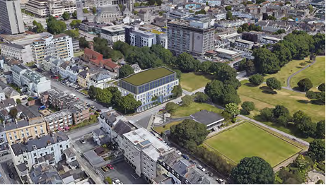
Aerial view towards south elevation (Lockyer Street to the left)

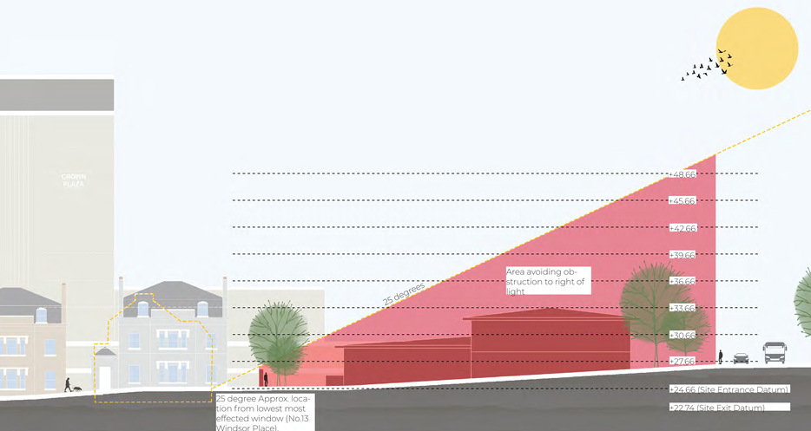
Daylight appraisals effect on nearby dwellings

APPENDIX 1 (continued)
25/01654/FUL - Plymouth Register Office, 49 Lockyer Street

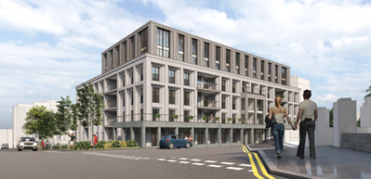
View from Citadel Rd looking east

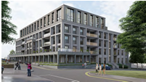
View from Citadel Rd looking west

APPENDIX 1 (continued)
25/01654/FUL - Plymouth Register Office, 49 Lockyer Street

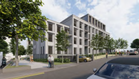
View from Lockyer St looking south

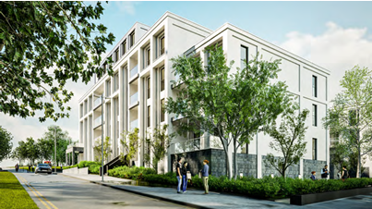
View from Armada Way looking south

APPENDIX 2
25/01341/FUL - Peace Garden, The Hoe.
Installation of Ebb and Flow sculpture, and accompanying plaque, within the Peace Garden.
Commissioned by PCC to commemorate the 80th Anniversary of VE Day.
The sculpture’s design is intended to recognise the largely unseen emotional challenges faced by Service Families. It is representative of the feelings and experiences of absence whilst parents are away on duty and is a direct response to the poetry of children belonging to Plymouth’s Military Kids Clubs and influenced by the artists’ own service. The sculpture is life size with the adult being 1.895m (6’2”).
PCC plan to relocate the sculpture from its current Civic square site, outside PCCs Council House, to The Hoe’s Peace Garden.
This sculpture previously featured in the news after its inauguration, the news article stated:
News Article
Plymouth council hits out at 'unpleasant and disrespectful' comments over new military sculpture
A new sculpture has been unveiled in Plymouth, inspired by military families with absent parents - but the city council says it has received hundreds of 'unpleasant and disrespectful' online comments about it.
The 'Ebb and Flow' artwork in Civic Square was created by Babcock International in partnership with Arts University Plymouth. They worked with children who sharing their feelings about missing a parent away on deployment.
But the council says some of the 'unkind' reaction to the piece has 'crossed a line'.
Councillor Pauline Murphy said: “The fact that this whole endeavour was done through goodwill makes it particularly disappointing that some people felt the need to be unpleasant about it in response to our social media post.
"While we can’t expect everyone to feel the same about any artwork, there is no reason to be unkind about something that a lot of people gave their time, talent and heart to create.
“Anyone who took the time to read the post would also have seen that the sculpture was manufactured and gifted by Babcock and was not created using council money. We will not let the disrespectful comments we received discourage us from working in partnership with others in the city in future to show support for Plymouth’s armed forces community.”
The sculpture was designed by Arts University Plymouth student David Beasley and developed with fellow students Ant Hill, Lucy Claire Walker, Doron Britz and Claire Jones.
David said: “There was an email calling for students interested in participating in the Remembrance Day project, and I thought, being ex-military, I’d like to get involved."
David worked with the 'Never Such Innocence' charity and military kids clubs on the project, hearing stories about separation within military families. One of the young girls talked about how she just wanted to hug her dad when he was away. That got me thinking that the hug is a big thing.
"I looked at the idea more closely. It’s the hug goodbye when they go away and the hug they get when they come back. "I came up with the adult and child figure almost hugging, designing the two figures so one would disappear when the other was in view. That’s how it evolved. I made a stack of maquette models out of cardboard to see how things would work.”

APPENDIX 2 (continued)
25/01341/FUL - Peace Garden, The Hoe.

The Hoe Neighbourhood Forum
We would like to object to this planning application: Whilst the sculpture is welcomed it is felt by many members that the Peace Garden is not the ideal location. It was also felt that removal of the seating would reduce the areas of separated quiet contemplation from three to two.
The HNF would like to point out that there has been no consultation regarding this proposal and given that councillors attend our regular monthly meetings it would have been courteous to have done so.
We also ask what other locations PCC identified for this sculpture and why these were rejected in favour of the Peace Garden? Why not leave it where it is in the Civic Square?
Lastly, we agree with The Gardens Trust that there needs to be a policy to steer what is and what is not acceptable within The Hoe landscape areas and the extent to which further sculptures, memorials and art installations will be permitted in the future. The Forum would welcome the opportunity to collaborate on such a policy.

PCC Natural Infrastructure team
While this application/site is located within designated greenspace, our position is that this installation does not detract from the functioning of the greenspace and as such we would not object or have any further comment on greenspace impacts.

Gardens Trust
We have liaised with our colleagues in the Devon Gardens Trust and their local knowledge informs this joint response. The Gardens Trust recognise that there are already a number of public memorials and monuments around The Hoe dating from the late 19th century to most recent additions. Therefore, whilst another new sculpture follows on with this tradition, we would be grateful to know if there is a Conservation Management Plan for The Hoe and/or whether there is a policy to steer what is and what is not acceptable within the landscape and the extent to which further sculptures, memorials and art installations will be permitted in the future. Other than this, we have no further comments to make at this stage. We would, however, emphasise that this does not signify in any way either our approval or disapproval of these proposals.

Historic England
Historic England provides advice when our engagement can add most value. In this case we are not offering advice. This should not be interpreted as comment on the merits of the application.
We suggest that you seek the views of your specialist conservation and archaeological advisers.

APPENDIX 2 (continued)
25/01341/FUL - Peace Garden, The Hoe.
PCC Historic Environment Officer
Summary
• Harm to significance of Listed Building (NPPF 2024)
• Harm to significance of Conservation Area (NPPF 2024)
• Harm to the setting of heritage assets (NPPF 2024)
• Clear and convincing justification not provided (NPPF 2024)
• Less than substantial harm not outweighed by public benefit (NPPF 2024)
• Does not preserve the Listed Building, its setting or its historic or architectural features (1990 Act)
• Does not preserve or enhance the character or appearance of the Conservation Area (1990 Act)
• Does not sustain local character or distinctiveness by conserving and where appropriate enhancing its historic environment, both designated and non-designated heritage assets and their settings (DEV21)

Building and Site
The applicant proposes to install a sculpture on The Hoe. The proposal site lies within the settings of a number of Listed Buildings including: Plymouth War Memorial (Grade I); The Esplanade, 1 to 8 and Forecourt Walls and Railings (Grade II*); Plymouth Conservative Club and attached Forecourt Railings 1 and 2 Lockyer Street (Grade II); Numbers 3 and 4 Lockyer Street and Forecourt Railings (Grade II); Gate Piers at South End of Lockyer Street (Grade II). The proposal site also lies within The Hoe Conservation Area, and The Hoe Registered Park and Garden (Grade II).
Assessment
The Design and Access Statement states that the sculpture is intended to represent the feelings of absence that Service Families feel whilst parents are away on duty. The proposed sculpture depicts two simplistic human silhouette figures constructed of a number of flat plates of polished steel bolted together, and a separate information plaque.
The proposal site is located due west of the Plymouth Naval War Memorial and due east of the street The Esplanade and adjacent to the south end of Lockyer Street. It occupies a piece of land south of The Bowling Green and north of The Hoe Promenade. The proposed location of the sculpture is a highly sensitive location. It lies within a group of heritage assets including the Grade I Listed Building Plymouth Naval War Memorial; the Citadel Scheduled Monument and within The Hoe Conservation Area and The Hoe Registered Park and Garden.
The Listed Building the Plymouth Naval War Memorial (Grade I) is described in its listing as a War Memorial unveiled in 1924 and a Second World War extension unveiled in 1954, of Portland stone ashlar with large copper sphere and bronze plaques. In the form of a massive stone obelisk with four ships’ prows projecting from the apex with a stepped square base and corner projections each with a lion couchant. Also described are the numerous bronze figures, sculptures and motifs, plaques and inscriptions, depicting naval symbols and personnel. It has historic interest as an eloquent tribute to those who served with the Royal Navy and the sacrifices they made in both the First and Second World Wars, commemorating those who have no grave but the sea. Its architectural interest is as a powerful naval symbol in the form of a rostral column intended as a mark for shipping, the Second World War extension making an architectural contribution to the dignity and contemplative quality of the memorial as a whole, and enhancement by distinguished sculpture on naval themes adds sculptural interest. The listing also refers to the group value of the Memorial with the registered Hoe Park, and a number of other nearby Memorials which are also Listed Buildings, two Grade II* and a Grade II.
The Listed Building The Esplanade, 1 to 8 and Forecourt Walls and Railings (Grade II*) is described in its listing as a planned terrace of villas dating from 1836 by George Wightwick, of stucco with stucco detail, dry slate mansard roofs, hipped behind parapets. On a double depth plan and three storeys and attic with symmetrical fenestration and with numerous surviving decorative architectural details described. Also included in the listing are the forecourt walls with plinth band and square coping surmounted by original wrought iron railings with turned finials and stanchions. Described as a fine example of its type, and part of an important planned group of terraces and villas by Foulston and Wightwick on The Hoe, “a scheme which placed Plymouth at the forefront of town planning in the early/mid 19th century”.

APPENDIX 2 (continued)
25/01341/FUL - Peace Garden, The Hoe.
PCC Historic Environment Officer (continued)
The Listed Building Plymouth Conservative Club and attached Forecourt Railings 1 and 2 Lockyer Street (Grade II) is described in its listing as a pair of houses in a planned terrace, now a club, dating from the mid 19th century of stucco with tiled mansard roof over moulded parapet cornice. On a double depth plan and of three storeys plus attic over basement with symmetrical fenestration and stucco details including Tuscan porch with moulded entablature and with a central pair of doorways and with numerous surviving decorative architectural details described. Also included is the low freestone forecourt plinth surmounted by original wrought iron railings with cast iron finials in bays between arched open piers with anthemion decoration and turned cast iron columns/lamp standards flanking the entrance. Also described as part of an important planned group of terraces and villas by Foulston and Wightwick on the Hoe “a scheme which placed Plymouth at the forefront of town planning in the early/mid 19th century”.
The Listed Building Numbers 3 and 4 Lockyer Street and Forecourt Railings (Grade II) is similar to 1 and 2 Lockyer Street and similarly described in its listing. It it also described as forming part of the important planned group of terraces and villas by Foulston and Wightwick on the Hoe “a scheme which placed Plymouth at the forefront of town planning in the early/mid 19th century”.
The Listed Building Gate Piers at South End of Lockyer Street is described in its listing as Gate Piers at the end of a planned street dating from the mid 19th century. A pair of square on-plan rusticated granite ashlar gate piers with plinths and moulded cornices surmounted by turned finials and also part of the important planned group of terraces and villas on The Hoe.
The Hoe Conservation Area Appraisal and Management Plan (CAAMP) by Plymouth City Council 2008 describes the drama of the topography of The Hoe, the grand vista across Plymouth Sound and the “serene and calm” of the location, described as “one of the great world views”. The document refers to the rich historical associations of the location and its extensive legacy of fine buildings and monuments. The post World War II town plan by Patrick Abercrombie, the largest and most ambitious urban design of the foremost post war UK city planner, is focussed on the Plymouth Naval War Memorial.
The Appraisal document describes Hoe Park as “one of the finest settings in the world”.
The Hoe CAAMP identifies the overall quality of the built environment as very high, containing a Scheduled Monument, Registered Park and Garden, 54 Listed Buildings, and 34 buildings which make a particular contribution to the Conservation Area. The public realm is described as having spectacular setting and views “characterised by an overwhelming sense of openness and space” a “place to stroll and enjoy”.
The proposal site is therefore located in a highly sensitive location.
Negative issues identified in the Management Plan include inappropriate and insensitive modern development, mundane and poor quality development, emphasised by their juxtaposition to the generally high quality historic buildings within the Conservation Area, and the use of unsympathetic modern materials and finishes. The principles to be followed in respect of development proposals are set out in the Council’s Management Plan and include the requirement for the position, scale, massing and materials of new development to respect the existing character of the Conservation Area and to be of the highest quality design that respects and enhances its character. Hoe Park and waterfront are described as “the jewel in the crown of the Conservation Area”.
The Hoe Registered Park and Garden is described in its listing as becoming increasingly formal from the early 19th century with walks and gardens complementing the adjacent residential developments, and by 1873 was described as public gardens with paths and shrubberies, a promenade and carriage drive. The area north of the Hoe Promenade is described as predominantly laid out as lawns planted with scattered specimen trees and including a straight tree lined walk and curvilinear walk and various features such as a 19th century drinking fountain, and granite obelisk. The Listed Plymouth Naval War Memorial is also included as a feature within the Registered Park and Garden with reference to the choice of it as the terminal feature of a new north-south vista extending through the city centre. Also included is a reference to the early 20th century bowling green on an artificial raised terrace and mid 20th century pavilion.

APPENDIX 2 (continued)
25/01341/FUL - Peace Garden, The Hoe.
PCC Historic Environment Officer (continued)
Conclusion and Recommendation
When considering whether to grant Listed Building Consent, the Local Planning Authority shall give special regard to the desirability of preserving the listed building or its setting or any features of special architectural or historic interest which it possesses, as set out in Section 66 of the Planning (Listed Buildings and Conservation Areas) Act 1990.When considering developments that affect a designated Conservation Area, the Local Planning Authority shall give special attention to the desirability of preserving or enhancing the character or appearance of that area, as set out in Section 72 of the Planning (Listed Buildings and Conservation Areas) Act 1990.
The National Planning Policy Framework 2024 states that Local planning authorities need to take OFFICIAL account of the desirability of sustaining and enhancing the significance of heritage assets (Para 210). The NPPF 2024 also states that great weight should be given to the conservation of a heritage asset (Para 212) and that any harm to or loss of significance should require clear and convincing justification (Para 213). The NPPF 2024 states that where a development proposal will lead to less than substantial harm to the significance of a designated heritage asset, this harm should be weighed against the public benefits of the proposal (Para 215).
Policy DEV21 states that development proposals need to sustain the local character and distinctiveness of the area by conserving and where appropriate enhancing its historic environment, both designated and non-designated heritage assets and their settings.
The applicant has submitted a drawing of the proposed sculpture which is to be constructed of two separate parts, each of a series of vertical steel plates bolted together and each part standing on its own metal plate base to be bolted to the ground. Each base is 800mm in diameter and the footprint of the whole sculpture is approximately 2m x 1m, and the sculpture is to be approximately 2m in height. Also proposed is a separate freestanding plaque (300mm x 420mm x 10mm) constructed of polished stainless steel plate on a stainless steel box section upright standing on a circular metal base and approximately 1.1m in height.
The proposed location is described in the Design and Access Statement as flat, open and accessible to all, in prime eye line of the Plymouth Naval War Memorial and visible to pedestrians walking along the footpath beside the garden. Two existing benches are intended to be relocated to make space for the proposed sculpture.
The proposed sculpture depicts two simplistic human silhouette figures each constructed of a number of flat plates of polished steel bolted together, and a separate steel information plaque. The proposed sculpture and plaque are of a stark, mechanical, engineering appearance with a functional, industrial character. The design, material and finish of the proposed sculpture and plaque are not considered to be sympathetic to the overall character of the nearby Listed Buildings and their settings, The Hoe Conservation Area, nor the Registered Park and Garden but to be harmful to their significance, character and appearance.
In addition, the proposal to remove two existing seats appears to undermine the purpose of the existing area the Peace Garden which is for quiet and peaceful contemplation and thought, and the existing seats provide the opportunity for everyone to do so here, enabling the purpose of the garden.
The proposal positions the sculpture not far from the Plymouth Naval War Memorial, a location which is almost sacred in its nature as it provides members of the public with a site at which to contemplate and consider the war dead of two World Wars commemorated by, and whose names are recorded on, the War Memorial, and to think of their ultimate sacrifice. The War Memorial is also in view as travellers walk along Hoe Promenade and along the walkways towards it, allowing a wider impact of the commemoration and longer consideration of the purpose of the War Memorial on the slow approach to it.
The installation of the proposed sculpture in this location does not appear compatible with the description of the location in The Hoe CAAMP as one of the finest settings in the world, with rich historical associations and the extensive legacy of fine buildings and monuments, nor to respect the overall very high quality of the existing built environment within the Conservation Area. Also, the proposal does not appear to comply with the principles set out in the Management Plan but introduces inappropriate and insensitive modern development using unsympathetic modern materials and finishes, which are identified in the CAAMP as negative issues within the Conservation Area.

APPENDIX 2 (continued)
25/01341/FUL - Peace Garden, The Hoe.
PCC Historic Environment Officer (continued)
This proposal is not considered to sustain or enhance the significance of the Listed Building the Plymouth Naval War Memorial because of its impact on its setting but is considered to be harmful to it and to the Conservation Area, its significance, character and appearance. Although the harm is considered to be less than substantial, for the purposes of the NPPF 2024, that harm is required to be outweighed by public benefit. There appears to be no special reason for the proposed location of this sculpture within this group of Listed
Buildings and adjacent to the Plymouth Naval War Memorial and there appear to be numerous alternative locations to position the figures. The applicant has not provided clear and convincing justification for the harm to the heritage assets affected, as required by the NPPF. The applicant has not provided details of any public benefit from the proposal and it is considered that if there is public benefit from siting the sculpture at this location, compared to an alternative location, then it would be insufficient to outweigh the harm to the various heritage assets from the proposal, as is required by the NPPF.

In addition, the Plymouth Naval War Memorial is a Grade I Listed Building and such Listed Buildings are described by Historic England as “of exceptional interest” and only around 2.5% of Listed Buildings are Grade I. The NPPF considers Grade I Listed Buildings to be “of the highest significance”. The Esplanade, 1 to 8 and Forecourt Walls and Railings is also a Grade II* Listed Building and this is also considered by the NPPF as “of the highest significance” and by Historic England as “particularly important buildings of more than special interest”.

For the above reasons this proposal is not considered to comply with the provisions of Policy DEV21 of the Plymouth and South West Devon Joint Local Plan, the NPPF (2024), and the relevant duties under the Planning (Listed Buildings and Conservation Areas) Act 1990.

Recommendation is therefore not to support this proposal.

APPENDIX 2 (continued)
25/01341/FUL - Peace Garden, The Hoe.
PCC Design and Conservation Team Manager
The purpose of this note is to clarify the position of the design and conservation team. It does not seek to question or revise the professional assessments already made but adds clarity on levels of harm and introduces additional views, including my own.
The officer rightly points out the importance of the site from a heritage perspective, as well as the setting which includes views and the approach to important listed buildings and structures within the CA and registered park itself.
The officer also rightly draws attention to the CA management plan, which sets out issues of using unsympathetic modern materials and finishes within the conservation area.
On this point, I note that the document is specifically discussing poor quality alterations to existing buildings as opposed to the introduction of structures in the public realm. For clarity, there is no blanket objection to the introduction of contemporary design within the conservation area. “Conservation” does not mean “preservation in aspic” and sympathetic modern design can enhance some heritage assets. The question here is whether the proposal meets the threshold for quality.
The officer also points out that if harm is identified, then a clear and convincing justification is necessitated by the NPPF and public benefits need to be demonstrated. They are correct that the Heritage Statement makes no assessment of the potential harm to and potential public benefits of the proposal to the setting of the majority of heritage assets impacted by the proposal. This fact is a serious omission and the officer is right to point it out. The council’s own assessment must therefore be made in isolation.
The assessment is the considered professional view of the officer who is fully qualified and has significant experience in heritage matters.
Level of harm and public benefit.
I do think it is worth clarifying that while identified as potentially harmful (rightly assessed correctly as the most common “Less Than Substantial” in NPPF terms), I believe any harm should be considered as very low. Clarity on the level of harm is needed in order to facilitate a balanced decision making by planning officers.
Also of relevance to the consideration of harm is that the installation is fully reversible, relatively small scale, and partially screened from view. Mature vegetation provides a further backdrop in views towards the sculpture that will diminish its visual prominence. This in itself does not prevent harm, but does relate to potential impact.
Public art is often controversial. In principle, the team support high quality public art.
Appearance/aesthetics are, of course, subjective to a degree, but professional assessment must be given appropriate weight.
Upon further discussion with colleagues, there are mixed views on the current proposal. However, it does have support from democratically elected members. I have also discussed with some officers within my own team (and other council teams) who are positive about the sculpture. I happen to share this view from an urban design perspective.
I also think that the “meaning” of the sculpture is fully aligned with the military, commemoration and reflection theme of the surrounding assets.
I therefore suggest that the Peace Garden location is appropriate for a sculpture of this type.

APPENDIX 2 (continued)
25/01341/FUL - Peace Garden, The Hoe.
PCC Design and Conservation Team Manager (continued)
Conclusion:
The Historic Environment Officer fulfilled their duties by providing a considered and professional view on the proposals and I do not question their analysis and professional opinion.
However, given that there are mixed views on the design, including many in support, the case officer may wish to consider whether this amounts to public benefit (cultural/social/meaning/aesthetic) through enhancement of the open space, which can be weighed against any potential harm to heritage assets.

Plymouth City Council Planning Committee Service Director Referral Form
The scheme has been discussed with senior managers, and it has been agreed that there are no financial/public interest reasons why the application should go to committee. There have been no public comments on the application.
Therefore there are no reasons for the matter to be determined by the Planning Committee.

PCC Planning Application Officers Report
This application has been considered in the context of the development plan, the NPPF, and other material considerations as set out in Section 7.

The JLP policies relevant to this application are SPT1 (Delivering sustainable development), SPT11 (Strategic approach to the historic environment), DEV1 (Protecting health and amenity), DEV2 (Air, water, soil, noise, land and light), DEV20 (Place shaping and the quality of the built environment), DEV21 (Development affecting the historic environment), DEV26 (Protecting and enhancing biodiversity and geological conservation), DEV27 (Green and play spaces), DEV28 (Trees, woodlands and hedgerows), DEV32 (Delivering low carbon development), and DEV35 (Managing flood risk and water quality impacts).

Design and Heritage Impacts
Officers note the concerns raised relating to the proposed sculpture. Both the Historic Environment Officer and the Hoe Neighbourhood Forum have expressed objections to the proposal - which largely focus on the design itself as a more modern structure and the harm which it would cause on the setting of a number of listed buildings, the listed Park and Garden, and the conservation area. Officers also note that the applicant's Heritage Statement fails to consider the level of harm which would be caused nor offers any public benefits as mitigation.

Despite this, Officers do not consider the level of harm which the proposal would cause sufficient to warrant a refusal of planning permission. It is noted that the other statues and memorials around the Hoe are more traditional in nature, with the latest addition depicting former Plymouth MP Nancy Astor perhaps more traditionally in-keeping with other similar statues, but Officers are not of the view that more modern-looking additions to the Hoe should be resisted in principle. The more clean-cut nature of the proposal does differ, therefore, but the overall scale of it is relatively modest compared to other such monuments. The figures are essentially 'life size', which is typical of statues, but the other statues on the Hoe, including the aforementioned Astor example and others including Sir Francis Drake, are sited on plinths - making them much larger. The other, non-statue, memorials, etc., also sited on the Hoe are much larger than what is proposed here - with the main Naval memorial significant in size. As such, it is not the view of Officers that the sculpture proposed would have a significant impact on the setting of these listed structures - as it would be dwarfed in size by all of them. It would be visible in wider views of some - but not at a level which would cause significant harm.

APPENDIX 2 (continued)
25/01341/FUL - Peace Garden, The Hoe.
PCC Planning Application Officers Report (continued)
The Peace Garden area itself is a fairly small area of the wider Hoe - and is relatively screened, particularly from Lockyer Street. As such, this would further limit the impact of the structure from wider views of the Hoe and its monuments. Given the overall meaning of the sculpture, too, Officers consider that it is thematically appropriate to locate it in the Peach Garden - which is an area for quiet reflection, either on the specific memorials within it or the wider ones situated throughout the Hoe. As such, the Peace Garden is considered an appropriate location for this reason. Officers do note that some benches within the relevant part of the Peace Garden would be moved, but as they would be re-located elsewhere in the Peace Garden this is not considered to be a concern.
It is considered, therefore, that the scheme would lead to less than substantial harm to the setting of nearby listed buildings/structures, the listed Park and Garden, and the wider conservation area - but that the level of harm, due to the size of the sculpture and its relatively secluded location, would be at the lower end of such. Paragraph 215 of the NPPF requires sufficient public benefits to outweigh any harm caused - and Officers are of the view that sufficient public benefit can be found in the reflective nature of the sculpture within the Peace Garden, an in-principle support of good-quality public art, and the links to Plymouth's naval heritage.
As such, Officers consider that the scheme is acceptable in both design and heritage contexts and would accord with DEV20 and DEV21 of the JLP.
Amenity Impacts
Officers do not consider that the proposed location of the sculpture, which would be largely screened from nearby residential properties, would be of a size or in a location to have amenity impacts in line with DEV1 and DEV2 of the JLP. Biodiversity Net Gain and Ecological Impacts Due to the size of the proposal, Officers consider that the scheme would be exempt from the mandatory BNG condition. Looking at its ecological impacts more widely, Officers do not have concerns. The Hoe is designated as greenspace, but the sculpture would not impact on its function - so no concerns are raised in context of the DEV27. The sculpture would be placed on existing hard surfaced ground, too, meaning that nearby trees would be unaffected. The Natural Infrastructure Team raised no objections to the proposal.
As such, the scheme is considered to accord with DEV26, DEV27, and DEV28 of the JLP.
Other Impacts
The site falls within a Critical Drainage Area, but the proposal would not increase the flood risk of the area nor alter any existing drainage arrangements. As such, no concerns have been raised in the context of the DEV35 of the JLP.
Additionally, the scheme is not considered large enough to necessitate any low carbon mitigation measures in line with DEV32 of the JLP nor the CEPS.
Conclusions and Reasons for Decision
Officers have taken account of the NPPF and S38(6) of the Planning and Compulsory Purchase Act 2004 and concluded that the proposal accords with policy and national guidance and is therefore recommended for conditional approval.
Permission Granted

ADDENDUM A
Planning – Viewing applications
You can view any of the planning applications listed below by visiting
https://planning.plymouth.gov.uk
and searching using the planning application number or address shown below.
~~~~~~~~~~~~~~~~~~~~~~~~~~~~~~~~~~~~~~~~~~~~~~~~~~~~~~~~~~~~~~~~~~~~~~~~~~~~~~~~~~~~
Planning - Commenting on applications
Comments can be submitted to Plymouth City Council by the methods below. Please include your name, address and the application number and clearly state if you ‘Object’ or ‘Support’ the application
- Email to: planningconsents@plymouth.gov.uk
- By post to: Strategic PCC Planning and Infrastructure, Floor 2, Ballard House, West Hoe Road, Plymouth, PL1 3BJ
- PCC Public Access Portal – You will need to have, or set up, a personal account for PCC access
~~~~~~~~~~~~~~~~~~~~~~~~~~~~~~~~~~~~~~~~~~~~~~~~~~~~~~~~~~~~~~~~~~~~~~~~~~~~~~~~~~~~
Planning – Reporting unauthorised developments:
https://www.plymouth.gov.uk/report-alleged-unauthorised-development
~~~~~~~~~~~~~~~~~~~~~~~~~~~~~~~~~~~~~~~~~~~~~~~~~~~~~~~~~~~~~~~~~~~~~~~~~~~~~~~~~~~~~
Licensing - Commenting on applications
https://licensing.plymouth.gov.uk/1/WcaHome
~~~~~~~~~~~~~~~~~~~~~~~~~~~~~~~~~~~~~~~~~~~~~~~~~~~~~~~~~~~~~~~~~~~~~~~~~~~~~~~~~~~~~
Report Noise Issues (businesses or neighbours)
https://www.plymouth.gov.uk/noise

